Configure workflow steps
When configuring workflows you have four major areas to consider:
- When to start them?
- Should they run as a real-time workflow or a background workflow?
- What actions should they perform?
- Under what conditions actions should be performed?
The topic Workflow processes introduced how to find workflow processes, when to start them, and if they should run as real time or background. This topic focuses on specifying what actions workflows can perform and specifying conditions to perform those actions.

In This Topic

Workflow stages and steps
Actions that workflow processes can perform
Setting conditions for workflow actions
Using real-time workflows

Workflow stages and steps

When you design workflows you have the option to contain the logic you want to perform in stages and steps.
Stages
Stages make the workflow logic easier to read, and explain the workflow logic. However, stages do not affect the logic or behavior of workflows. If a process has stages, all the steps within the process must be contained with a stage.
Steps
Steps are a unit of business logic within a workflow. Steps can include conditions, actions, other steps, or a combination of these elements.

Actions that workflow processes can perform

Workflow processes can perform the actions listed in the following table.

Action | Description
Create Record | Creates a new record for an entity you choose and assigns values you choose to attributes.
Update Record | You can update the record that the workflow is running on, any of the records linked to that record in an N:1 relationships, or any records created by earlier steps.
Assign Record | You can assign the record that the workflow is running on, any of the records linked to that record with an N:1 relationship, or any records created by earlier steps.
Send Email | Sends an email. You can choose to create a new email message or use an email template configured for the entity of the record that the workflow is running on or any entities that have an N:1 relationship with the entity, or the entity for any records created by earlier steps.
Start Child Workflow | Starts a workflow process that has been configured as a child workflow.
Change Status | Changes the status of the record that the process is running on, any of the records linked to that record with an N:1 relationship, or any records created by earlier steps.
Stop Workflow | Stops the current workflow. You can set a status of either Succeeded or Cancelled and specify a status message.  When real-time workflows are configured for an event, stopping a workflow with a status of cancelled will prevent the event action from completing. See Using real-time workflows for more information.
Custom Step | Developers can create custom workflow steps that define actions. There are no custom steps available in Microsoft Dynamics CRM by default.

Setting record values

When you create a record you can set values for the record. When you update a record you can set, append, increment, decrement, multiply, or clear values.
When you click Set Properties, a dialog opens showing you the default form for the entity.
At the bottom of the dialog you can see a list of additional fields not present in the form.
For any field, you can set a static value and that will be set by the workflow.
On the right side of the dialog the Form Assistant gives you the ability to set or append dynamic values from the context of the current record. This includes values from related records that can be accessed from the N:1 (many-to-one) relationships for the entity.
The options available in the Form Assistant depend on the field you have selected in the form. When you set a dynamic value, you will see a yellow placeholder known as a ‘slug’ that shows where the dynamic data will be included. If you want to remove the value, just select the slug and delete it. For text fields, you can use a combination of static and dynamic data.
With dynamic values you don’t know for certain that a field or related entity has the value you want to set. You can actually set a number of fields to try and set the value and sort them in order using the green arrows. If the first field doesn’t have data, the second field will be tried and so on. If none of the fields have data, you can specify a default value to be used.

Setting conditions for workflow actions

The actions that you will apply often depend on conditions. Workflow processes provide several ways to set conditions and create branching logic to get the results you want. You can check values of the record that the workflow process is running against, any of the records linked to that record with an N:1 relationship, or values within the process itself

Condition Type | Description
Check Condition | A logical "if-<condition> then" statement.  You can check values for the record that the workflow is running on, any of the records linked to that record in an N:1 relationships, or any records created by earlier steps. Based on these values you can define additional steps when the condition is true.  In the "if-<condition> then" statement, you can use the following operators: Equals, Does Not Equal, Contains Data, Does Not Contain Data, Under and Not Under.
  Note
  The Under and Not Under are hierarchical operators. They can only be used on the entities that have a hierarchical relationship defined. If you’re trying to use these operators on the entities that don’t have the hierarchical relationship defined, you’ll see the error message: “You’re using a hierarchical operator on an entity that doesn’t have a hierarchical relationship defined. Either make the entity hierarchical (by marking a relationship as hierarchical) or use a different operator.”
  For more information about hierarchical relationships, see Query and visualize hierarchical data.
  A screenshot that follows the table is an example of the definition of the workflow process that uses the Under and Not Under hierarchical operators.
Conditional Branch | A logical "else-if-then" statement, the editor uses the text “Otherwise, if <condition> then:”  Select a check condition you have previously defined and you can add a conditional branch to define additional steps when the check condition returns false.
Default Action | A logical "else" statement. the editor uses the text “Otherwise:”  Select a check condition, conditional branch, wait condition, or parallel wait branch that you have previously defined and you can use a default action to define steps for all cases that do not match the criteria defined in condition or branch elements.
Wait Condition | Enables a background workflow to pause itself until the criteria defined by the condition have been met. The workflow starts again automatically when the criteria in the wait condition have been met.  Real-time workflows cannot use wait conditions.
Parallel Wait Branch | Defines an alternative wait condition for a background workflow with a corresponding set of additional steps that are performed only when the initial criterion is met. You can use parallel wait branches to create time limits in your workflow logic. They help prevent the workflow from waiting indefinitely until the criteria defined in a wait condition have been met.
Custom Step | Developers can create custom workflow steps that define conditions. There are no custom steps available in Microsoft Dynamics CRM by default.
The following screenshot contains an example of the workflow process definition with the Under and Not Under hierarchical operators. In our example, we apply two different discounts to two groups of accounts. In Add Step, we selected the Check Condition to specify the if-then condition containing the Under or Not Under operators. The first if-then condition applies to all accounts that are Under the Alpine Ski House account. These accounts receive a 10% discount on purchased good and services. The second if-then condition applies to all accounts that are Not Under the Alpine Ski House account and they receive a 5% discount. Then, we selected Update Record to define the action to be performed based on the condition.

You can also see the Scope, when expanded, has the following options:
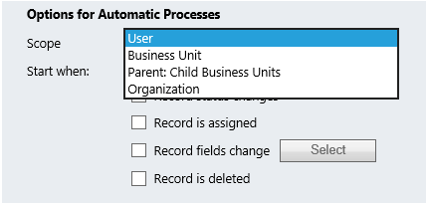
User– when this option is selected, the Workflow will exclusively run on records with the same owner as the Workflow.
Business Unit- when this option is selected, the Workflow will exclusively run on records owned by any user in the same Business Unit as the owner of the Workflow.
Parent: Child Business Units- when this option is selected, the Workflow will exclusively run on records owned by any user in the same Business Unit—or
Organization- when this option is selected, the Workflow will run on records owned by any user.

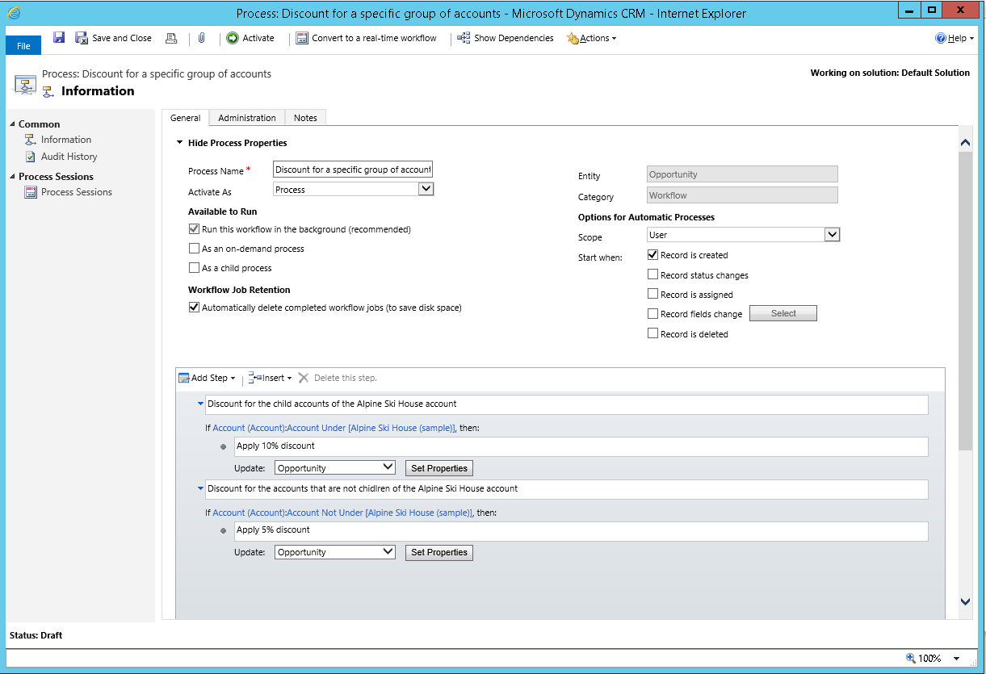

Using real-time workflows

With Microsoft Dynamics CRM, you can configure real-time workflows but you should use them with care. Background workflows are generally recommended because they allow the system to apply them as resources on the server are available. This helps smooth out the work the server has to do and help maintain the best performance for everyone using the system. The drawback is that actions defined by background workflows are not immediate. You can’t predict when they will be applied, but generally it will take a few minutes. For most automation of business processes this is fine because people using the system don’t need to be consciously aware that the process is running.
Use real-time workflows when a business process requires someone to immediately see the results of the process or if you want the ability to cancel an operation. For example, you may want to set certain default values for a record the first time it’s saved, or you want to make sure that some records are not deleted.

Converting between real-time and background workflows

You can change a real-time workflow into a background workflow by choosing Convert to a background workflow on the toolbar.
You can change a background workflow into a real-time workflow by choosing Convert to a real-time workflow on the toolbar. If the background workflow uses a wait conditions it will become invalid and you won’t be able to activate it until you remove the wait condition.

Initiating real-time workflows before or after status changes

When you configure Options for Automatic Processes for real-time workflows, the Start When options for the status changes event let you select After or Before for when status changes. The default option is After.
When you select Before you are saying that you want the logic in the workflow to be applied before data changing the status is saved. This provides you with the ability to check the values before other logic has been applied after the operation and prevent further logic from being performed. For example, you may have additional logic in a plugin or custom workflow action which could initiate actions on another system. By stopping further processing you can avoid cases where external systems are affected. Applying real-time workflows before this event also means that other workflow or plug-in actions in Microsoft Dynamics CRM that may have saved data don’t need to be “rolled back” when the operation is canceled.

Using the Stop Workflow action with real-time workflows

When you apply a Stop Workflow action in a workflow you have the option to specify a status condition that can be either Succeeded or Canceled. When you set the status to canceled, you prevent the operation. An error message containing the text from the stop action status message will be displayed to the user with the heading Business Process Error.
http://www.wipfli.com/BlogPost_MCRM_Blog_011315_RealTimeWorkflows.aspx
Real-Time Workflows in Microsoft Dynamics® CRM 2013 ---------------Imp

Best practices for workflow processes
Dynamics CRM 2015
Other Versions

This topic has not yet been rated - Rate this topic
Applies To: CRM 2015 on-prem, CRM Online
This topic contains best practices for creating and managing workflow processes.

In This Topic

Avoid infinite loops
Use workflow templates
Use child workflows
Keep fewer logs
Use Notes to keep track of changes

Avoid infinite loops

It’s possible to create logic in a workflow that initiates an infinite loop, which consumes server resources and affects performance. The typical situation where an infinite loop might occur is if you have a workflow configured to start when an attribute is updated and then updates that attribute in the logic of the workflow. The update action triggers the same workflow that updates the record and triggers the workflow again and again.
Microsoft Dynamics CRM includes logic to detect and stop infinite loops. If a workflow process is run more than a certain number of times on a specific record in a short period of time, the process fails with the following error: This workflow job was canceled because the workflow that started it included an infinite loop. Correct the workflow logic and try again. For Microsoft Dynamics CRM Online the limit of times is 16. For on-premises deployments of CRM, the limit is 8.

Use workflow templates

If you have workflows that are similar and you anticipate creating more workflows that follow the same pattern, save your workflow as a workflow template. This way, the next time you need to create a similar workflow, create the workflow using the template and avoid entering all the conditions and actions from scratch.
In the Create Process dialog, choose New process from an existing template (select from list).

Use child workflows

If you apply the same logic in different workflows or in conditional branches, define that logic as a child workflow so you don’t have to replicate that logic manually in each workflow or conditional branch. This helps make your workflows easier to maintain. Instead of examining many workflows that may apply the same logic, you can just update one workflow.

Keep fewer logs

To save disk space, clear the Keep logs for workflow jobs that encounter errors check box if you don’t need to keep this data.

Use Notes to keep track of changes

When you edit workflows you should use the Notes tab and type what you did and why you did it. This allows someone else to understand the changes you made.
- Check the Process Session... See below notes from the implementation guide

Monitoring real-time workflows and actions
Real-time workflows and actions do not use System Job records because they occur immediately. Any errors that occur will be displayed to the user in the application with the heading Business Process Error.
There is no log for successful operations. You can enable logging for errors by checking the Keep Logs for workflow jobs that encountered errors option in the Workflow Log Retention area at the bottom of the Administration tab for the process.
To view the log of errors for a specific process, open the real-time workflow or action definition and go to the Process Session tab. This will only show any errors logged for this process.
If you want a view of all the errors for any process, go to Advanced Find and create a view showing errors on the process session entity.
https://community.dynamics.com/crm/b/crmpowerobjects/archive/2014/04/24/where-did-my-dynamics-crm-2013-workflow-go
https://community.dynamics.com/crm/f/117/t/153108
https://community.dynamics.com/crm/f/117/t/153108

